XXVI Sandbjerg Symposium

Danish Society for Neuroscience

*Synaptic wiring specificity*

*and network dynamics*

*in the brain*

May 6-8, 2012

Sandbjerg Estate

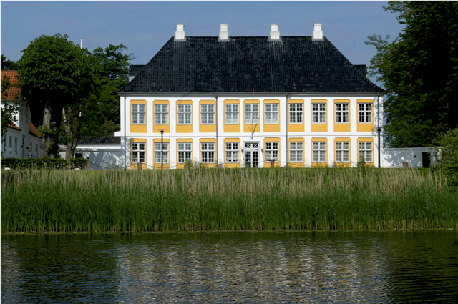

**Symposium organizers:**

Mai Marie Holm and Kimmo Jensen, Aarhus University, on behalf of the Danish Society for Neuroscience.

**Speakers:**

Brain Prize winners Péter Somogyi, Tamás Freund and György Buzsáki, in addition to invited international speakers from USA, Germany, Switzerland and UK.

**Place:**

Sandbjerg Estate, Sandbjergvej 102, DK-6400 Sønderborg, Denmark, www.sandbjerg.dk

**Winners of the Brain Prize 2011**

|  |  |  |
| --- | --- | --- |
|  |  |  |
| **György Buzsáki** – is Board of Governors Professor at the Center for Molecular and Behavioral Neuroscience, Rutgers University, Newark, New Jersey, USA. He has been a leader in analysing the physiological properties that arise from the anatomical and molecular characteristics defined by Somogyi, Freund and others. Buzsáki too has been a technical innovator, developing methods for recording activity at multiple points within circuits of nerve cells in awake, behaving animals. Particularly significant have been his direct observations and rigorous theoretical models of rhythmic activity, and his description of ways in which the dynamic characteristics of brain circuits might contribute to higher cognitive functions. | **Tamás Freund,** – is Director of the Institute of Experimental Medicine of the Hungarian Academy of Sciences, Budapest, Hungary. He has concentrated on the role of inhibitory ‘interneurons’ – small nerve cells that release the neurotransmitter γ-amino butyric acid (GABA), which reduces activity in nerve cells to which they connect. Freund and his group identified  in the hippocampus three novel types of such cells that connect to other inhibitory nerve cells.  He made the important discovery that control of  inhibitory interneurons by other inhibitory cells regulates rhythmic patterns of activity, which are essential for normal memory formation. He has also demonstrated that cannabinoid-related molecules – naturally occurring transmitters in the brain and certain drugs acting on the brain – work on a specific class of inhibitory nerve cells, and he has suggested ways in which failure of this mechanism might be involved in a variety of diseases. | **Péter Somogyi** – is Director of the Medical Research Council Anatomical Neuro-pharmacology Unit and Professor of Neurobiology,  Oxford, UK. He pioneered virtuosic methods for the characterization of nerve cell circuits, involving the identification of individual types of nerve cells based on their microscopic structure  and the neurotransmitter molecules that they use for communication, the ultra-structural specialization within the synaptic connections  between nerve cells, and the electrical responses that are generated at different kinds of synapses.Somogyi’s conceptual framework and multidisciplinary approaches to the study of the cerebral cortex leads to explanations of  chronocircuitry, a term he coined to reflect the unity of time and space in the brain. |

**Organizers:**

The Danish Society for Neuroscience in collaboration with the Grete Lundbeck European Brain Research Foundation and the prize winner(s) from the preceding year.

**Background:**

Once annually Grete Lundbeck European Brain Research Foundation awards The Brain Prize - a € 1 mio. personal prize. The prize is awarded as an important part of the aim of the Foundation:

– ‘*to boost interest in brain research and its results, to stimulate and reward outstanding brain research and to stimulate Danish research through an expanded inter­play with other European brain research, and thus to improve the scientific basis for progress in the prevention, diagnostics and treatment of diseases and disorders of the brain and nervous system*‘*.*

Prize recipients are expected to contribute to the advancement and internationalisation of Danish brain research through interaction with Danish researchers and research environments. The Prize is awarded to Péter Somogyi, Tamás Freund and György Buzsáki who will take part in organizing the meeting and will be in Denmark during the meeting.

The Danish Society for Neuroscience (DSfN) is a national association of neuroscientists and the society represents Danish neuroscience both nationally and internationally. Since its inauguration in 1984, DSfN has held its annual meetings at Sandbjerg Manor in Southern Denmark, always starting on the first Sunday in May.

Grete Lundbeck European Brain Research Foundation and the Brain Prize winners will collaborate with the Danish Society for Neuroscience in organizing the annual meeting. The meeting is part of the implementation of the planned outreach activities of the Foundation.

**Annual meeting:**The annual meeting is open to students, young scientists, PhD students, post. docs. and senior researchers that either are Danish neuroscientists or somehow are related to the Danish Neuroscience society.

The annual meeting in 2012 will have the overall theme: ***Synaptic wiring specificity and network dynamics in the brain*** as proposed by the prize winners Péter Somogyi, Tamás Freund and György Buzsáki.

**Program**

**Sunday 6 May**

13:00 – 14:15 Arrival and registration

14:30 – 14:45 Welcome

***Session 1***

*(Chaired by Gitte Moos Knudsen, University of Copenhagen, Denmark)*

14:45 – 15:30 Péter Somogyi (MRC Anatomical Neuropharmacology Unit, Oxford,

UK)

‘*GABAergic contribution to the chronocircuit of the hippocampus*’

15:30 – 16:15 Tamás Freund (Hungarian Academy of Sciences, Budapest, Hungary)

‘*Subcortical control of hippocampal activity via inhibitory interneurons*’

16:15 – 16:45 Coffee

16:45 – 17:30 György Buzsáki (Rutgers University, Newark, New Jersey, USA)

‘*Multiple subcircuits in the hippocampal CA1 region*’

17:30 – 18:00 Discussion

19:00 – Dinner

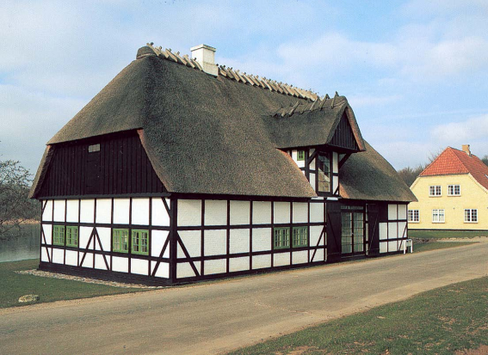

**Monday 7 May**

8:00 – 9:00 Breakfast

***Session 2***

*(Chaired by Mark West, Aarhus University, Denmark)*

9:10 – 9:40 Sebastian Seung (MIT, Cambridge, USA)

‘*Retinal cell types and their connections*’

9:45 – 10:15 Sonja Hofer (University College London, London, UK)

‘*Functional organization of synaptic connectivity in visual cortex and its postnatal development*’

10:20 – 10:50 Coffee

10:55 – 11:25 Nicoletta Kessaris (University College London, London, UK)

‘*Subpallial sources of cortical interneurons and the generation of diversity*’

11:30 – 12:00 Zoltan Molnar (University of Oxford, Oxford, UK)

‘*Formation of the earliest cortical circuits*’

12:00 – 13:00 Lunch

*Session 3*

*(Chaired by Bente Finsen, University of Southern Denmark)*

13:10 – 13:40 Pico Caroni (Friedrich Miescher Institute, Basel, Switzerland)

‘*Plasticity of principal neuron microcircuits in the hippocampus*’

13:45 – 14:15 Michael Brecht (Institut fur Neurobiologie, Berlin, Germany)

‘*The making of hippocampal maps*’

14:20 – 14:50 Coffee

15:00 – 15:30 Ed Callaway (Salk Institute, San Diego, USA)

‘*Rabies-based tools for elucidating neural circuits and linking connectivity to function*’

15:35 – 16:05 Troy Margrie (The National Institute for Medical Research, London, UK)

‘*Neuronal intrinsic biophysical diversity within and across functionally discrete networks*’

16:10 – 16:25 Break

16:30 – 17:00 Ed Lein (Allen Institute, Seattle, USA)

‘*Molecular approaches to understanding cellular diversity in the brain*’

17:00 – 18:00 Free time

19:00 – Gala Dinner

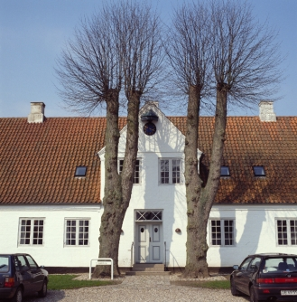

**Tuesday 8 May**

8:00 – 9:00 Breakfast

***Session 4***

*(Chaired by Mai Marie Holm, Aarhus University, Denmark*)

9:00 – 10:20 *Oral Communications from selected abstracts*

Jens C. Rekling (University of Copenhagen, Denmark)

*‘Development and possible function of olivocerebellar modules’*

Karin Lykke-Hartmann (Aarhus University, Denmark)

*‘An α2Na+/K+-ATPase knock-in mouse to model Familial Hemiplegic Migraine’*

Peter C. Petersen (University of Copenhagen, Denmark)

*‘Balanced excitation and inhibition during functional motor activity in the spinal cord’*

Simon Glerup Pedersen (Aarhus University, Denmark)

*‘SorCS2 in shaping neuronal connectivity and plasticity’*

10:20 – 10:40 Coffee

***Session 5***

*(Chaired by Kimmo Jensen, Aarhus University, Denmark)*

10:45 – 11:15 Jorn Hounsgaard (University of Copenhagen, Copenhagen, Denmark)

‘*Sensory–motor and motor–sensory transduction in the spinal cord*’

11:20 – 11:50 Mark West (Aarhus University, Aarhus, Denmark)

‘*Structural changes in the Alzheimer brain*’

11:50 Closure of meeting

12:00 – 13:00 Lunch

13:00 Departure

**Practical details:**

**Internet:**

There will be **wireless internet** in all buildings during the meeting.

**Posters:**

Posters presented by participants should be put up upon arrival and removed at the end of the meeting. All participants are encouraged to visit the poster area whenever convenient during the meeting. There will be no scheduled poster session.

**TAXI:**

Please contact *Sønderborg Taxa* at +45 74421818

**Map of Sandbjerg Castle:**

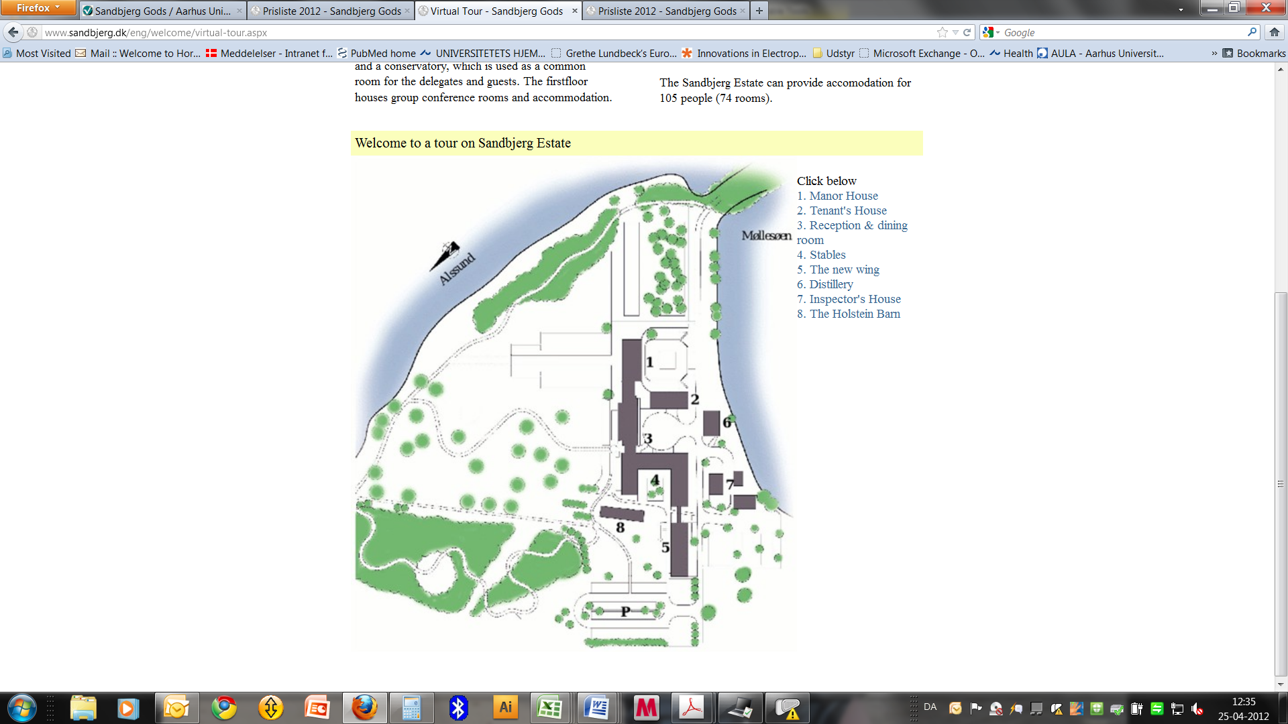

**The generous support from the following sponsors is greatly acknowledged**:

Grete Lundbeck European Brain Research Foundation, The Brain Prize

Graduate Program in Neuroscience, University of Copenhagen

Graduate Neuroscience Program, Aarhus University

Aarhus University

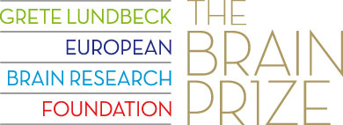



**List of participants:**

|  |  |  |  |  |
| --- | --- | --- | --- | --- |
| Olav | **Andersen** | Assoc. Professor | Dept. of Biomedicine, Aarhus University | o.andersen@biokemi.au.dk |
| Ambra | **Annibali** | Master student | Dept. of Biomedicine, Aarhus University | [aab@biokemi.au.dk](mailto:aab@biokemi.au.dk) |
| Maryam | **Ardalan** | Dr. | Dept. of Clinical Medicine, Aarhus University | maryan.ardalan@ki.au.dk |
| Janne | **Axelsen** | Int. Relations Manager | The Brain Prize | [ja@thebrainprize.org](mailto:ja@thebrainprize.org) |
| Rune | **Berg** | Post Doc | Dept. of Neuroscience and Pharmacology, University of Copenhagen | [runeb@sund.ku.dk](mailto:runeb@sund.ku.dk) |
| Michael | **Brecht** | Professor | Institut für Neurobiologie, Basel University | [michael.brecht@bccn-berlin.de](mailto:michael.brecht@bccn-berlin.de) |
| György | **Buzsáki** | Professor | Rutgers University | [buzsaki@andromeda.rutgers.edu](mailto:buzsaki@andromeda.rutgers.edu) |
| Ulrik | **Bølcho** | Post Doc | Dept. of Biomedicine, Aarhus University | [ub@fi.au.dk](mailto:ub@fi.au.dk) |
| Ed | **Callaway** | Professor | The Salk Institute for Biological Studies | [callaway@salk.edu](mailto:callaway@salk.edu) |
| Pico | **Caroni** | Professor | Friedrich Miescher Institute, Basel | caroni@fmi.ch |
| Gitte Bundgaard | **Christiansen** | PhD student | Dept. of Biomedicine, Aarhus University | [gbch@fi.au.dk](mailto:gbch@fi.au.dk) |
| Nils Henrik | **Diemer** | Professor | IMM, University of Southern Denmark | [ndiemer@health.sdu.dk](mailto:ndiemer@health.sdu.dk) |
| Zita | **Dosa** | PhD student | Dept. of Biomedicine, Aarhus University | [zd@fi.au.dk](mailto:zd@fi.au.dk) |
| Bente | **Finsen** | Professor | University of Southern Denmark | [bfinsen@health.sdu.dk](mailto:bfinsen@health.sdu.dk) |
| Tamás | **Freund** | Professor | Hungarian Academy of Sciences | [freund@koki.hu](mailto:freund@koki.hu) |
| Emilia | **Giannella** | Erasmus student | Dept. of Biomedicine, Aarhus University | [egia@fi.au.dk](mailto:egia@fi.au.dk) |
| Camilla | **Gustafsen** | Post Doc | Dept. of Biomedicine, Aarhus University | [cg@biokemi.au.dk](mailto:cg@biokemi.au.dk) |
| Mikkel | **Herly** | Student | Dept. of Neuroscience and Pharmacology, University of Copenhagen | [mikkelherly@gmail.com](mailto:mikkelherly@gmail.com) |
| Sonja | **Hofer** | Wellcome Trust Research Career Development Fellow | University College London | [s.hofer@ucl.ac.uk](mailto:s.hofer@ucl.ac.uk) |
| Mai Marie | **Holm** | Assoc. Professor | Dept. of Biomedicine, Aarhus University | [mmh@fi.au.dk](mailto:mmh@fi.au.dk) |
| Jørn | **Hounsgaard** | Professor | Dept. of Neuroscience and Pharmacology, University of Copenhagen | [jorndh@gmail.com](mailto:jorndh@gmail.com) |
| Henrik | **Jahnsen** | Assoc. Professor | Dept. of Neuroscience and Pharmacology, University of Copenhagen | [hjahnsen@sund.ku.dk](mailto:hjahnsen@sund.ku.dk) |
| Simon Mølgaard | **Jensen** | PhD student | Dept. of Clinical Medicine, Aarhus University | [smjensen@ki.au.dk](mailto:smjensen@ki.au.dk) |
| Kimmo | **Jensen** | Professor | Dept. of Biomedicine, Aarhus University | [kimmo@fi.au.dk](mailto:kimmo@fi.au.dk) |
| Nicoletta | **Kessaris** | Reader in Developmental Neuroscience | University College London | [n.tekki-kessaris@ucl.ac.uk](mailto:n.tekki-kessaris@ucl.ac.uk) |
| Gitte Moos | **Knudsen** | Professor | Neurobiology Research Unit, Rigshospitalet, | [gitte@nru.dk](mailto:gitte@nru.dk) |
| Kim | **Krogsgaard** | Director | The Brain Prize | [kk@thebrainprize.org](mailto:kk@thebrainprize.org) |
| Jørgen Scheel | **Krüger** | Professor | CFIN, Aarhus University | [kruger@cfin.dk](mailto:kruger@cfin.dk) |
| Mathias | **Kølvraa** | Stud med | Inst. for Neurovidenskab og Farmakologi | [mathiaskoelvraa@gmail.com](mailto:mathiaskoelvraa@gmail.com) |
| Sofie Cecilie | **Lange** | Cand Scient | Dept. of Drug Design and Pharmacology, University of Copenhagen | [scl@farma.ku.dk](mailto:scl@farma.ku.dk) |
| Ed | **Lein** | Senior Director | Allen Institute for Brain Science, Seattle | [edl@alleninstitute.org](mailto:edl@alleninstitute.org) |
| Hans | **Lou** | Professor | CFIN, Aarhus University | [hanslou1@gmail.com](mailto:hanslou1@gmail.com) |
| Karin | **Lykke-Hartmann** | Assoc. Professor | Dept. of Biomedicine, Aarhus University | [kly@biokemi.au.dk](mailto:kly@biokemi.au.dk) |
| Troy | **Margrie** | Professor | National Institute for Medical Research, London | [tmargri@nimr.mrc.ac.uk](mailto:tmargri@nimr.mrc.ac.uk) |
| Zoltán | **Molnár** | Professor | Department of Physiology, Anatomy and Genetics, University of Oxford | [zoltan.molnar@dpag.ox.ac.uk](mailto:zoltan.molnar@dpag.ox.ac.uk) |
| Felix C. | **Müller** | Stud. Med | Dept. of Neuroscience and Pharmacology, University of Copenhagen | [felix.c.mueller@gmail.com](mailto:felix.c.mueller@gmail.com) |
| Nicoletta | **Nava** | PhD student | Centre for Psychiatric Research, Aarhus University | [nicoletta.nava@ki.au.dk](mailto:nicoletta.nava@ki.au.dk) |
| Jakob Dahl | **Nielsen** | Cand Pharm | Dept. of Drug Design and Pharmacology, University of Copenhagen | [jdn@farma.ku.dk](mailto:jdn@farma.ku.dk) |
| Simon Glerup | **Pedersen** | Assist. Professor | Dept. of Biomedicine, Aarhus university | [sg@biokemi.au.dk](mailto:sg@biokemi.au.dk) |
| Peter | **Petersen** | PhD student | Dept. of Neuroscience and Pharmacology, University of Copenhagen | [petersen.peter@sund.ku.dk](mailto:petersen.peter@sund.ku.dk) |
| Ali H | **Rafati** | Dr. | Dept. of Clinical Medicine, Aarhus University | [ali.h.rafati@ki.au.dk](mailto:ali.h.rafati@ki.au.dk) |
| Jens | **Rekling** | Assoc. Professor | Dept. of Neuroscience and Pharmacology, University of Copenhagen | [jrekling@sund.ku.dk](mailto:jrekling@sund.ku.dk) |
| Sebastian | **Seung** | Professor | MIT | [seung@MIT.EDU](mailto:seung@MIT.EDU) |
| Petér | **Somogyi** | Professor | MRC Anatomical Neuropharmacology Unit | peter.somogyi@pharm.ox.ac.uk |
| Noemie | **Tentillier** | Research Assistant | Dept. of Biomedicine, Aarhus University | [noemiet@biokemi.au.dk](mailto:noemiet@biokemi.au.dk) |
| Karina Dvinge | **Thielsen** | Stud Scient | Dept. of Biomedicine, Aarhus University | [kdt@fi.au.dk](mailto:kdt@fi.au.dk) |
| Irina | **Vardya** | PhD | Dept. of Biomedicine, Aarhus University | [iv@fi.au.dk](mailto:iv@fi.au.dk) |
| Mikkel | **Vestergaard** | PhD student | Dept. of Neuroscience and Pharmacology, University of Copenhagen | [mikkelve@sund.ku.dk](mailto:mikkelve@sund.ku.dk) |
| Mark | **West** | Professor | Dept. of Biomedicine, Aarhus University | [mjw@ana.au.dk](mailto:mjw@ana.au.dk) |
| Ove | **Wiborg** | Assoc. Professor | Centre for Psychiatric Research, Aarhus University | [owiborg@post.tele.dk](mailto:owiborg@post.tele.dk) |
| Michael | **Winterdahl** | Post Doc | Aarhus PET Center, Aarhus University | [winterdahl@gmail.com](mailto:winterdahl@gmail.com) |
| Justyna | **Zareba** | PhD student | Dept. of Biomedicine, Aarhus University | [jzareba@biokemi.au.dk](mailto:jzareba@biokemi.au.dk) |
|  |  |  |  |  |

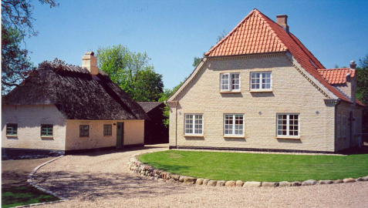

**NOTES:**